Emerald ash borer Michigan project – Hypotheses, methods, and results
Nov. 11, 2024
Aaron Tayal

Questions:
- Where are ash seedlings, saplings, and trees most abundant? Does this vary by hydrology of a transect?

- Which species of ash seedlings, saplings, small trees, and trees are found at each plot?

- What percentage of ash saplings, small trees, and trees have signs and symptoms of EAB attack? What minimum diameter of ash is EAB attacking? Does this vary by ash species? Are black ash or green/white/pumpkin ash dying at smaller sizes?

- How fast are ash saplings growing?

- What size of tree is required to produce seeds?

- In hydric forests, did canopy trees respond positively or negatively to ash mortality?

- In hydric forests, did existing advance regeneration (saplings and subcanopy trees) respond positively or negatively to ash mortality?

- In hydric forests which previously had high numbers of canopy ash trees, what vegetation is now found at the ground layer?

Hypotheses
- The abundance of ash at a given location could depend on multiple factors. These include propagule pressure and advanced regeneration, competition with other plants for sun, water, and/or nutrients, and mortality due to emerald ash borer.

  - Propagule pressure and advanced regeneration: The number of ash seeds falling on the ground in the past likely influences the current abundance of ash. Ash trees display a masting pattern of seed production. For white ash, masts occur approximately every third year, whereas black ash masts occur about 28% of years, and green ash seed production is more evenly distributed across years.¹ The seeds of ash are winged samaras, which allows them to disperse up to hundreds of feet in the wind, and possibly further if they travel through water-assisted dispersal.¹

The plots we visited in the Huron river watershed were selected based on a number of variables, but one of those was ash density (Smith 2006, pg. 39).² Each plot was required to have at least two mature ash trees in its 18 meter radius (Smith 2006, pg. 64), but some plots had many more ash trees. Generally, the three plots within a transect were intended as replicates of the same general stand characteristics.

Table. Copied from Smith 2006.² Variables related to tree composition of forest stands in 2004-2005 in the Huron river watershed. Note: Based on comparison with the table below, this table represents all stems above 2.5 cm DBH (meaning both understory trees and canopy trees).
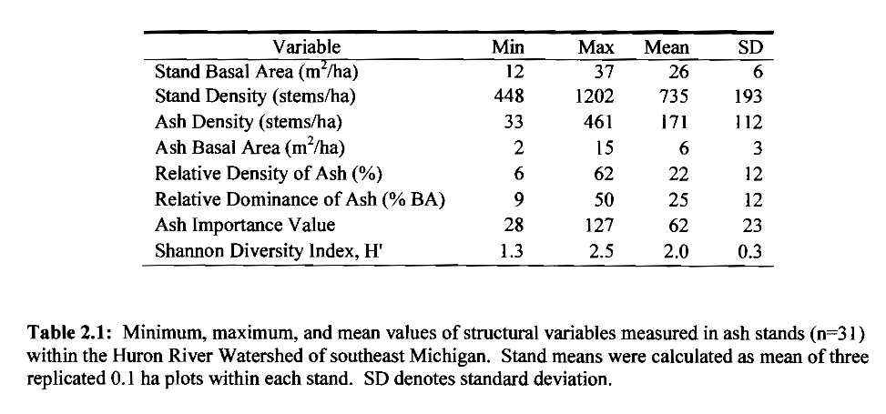

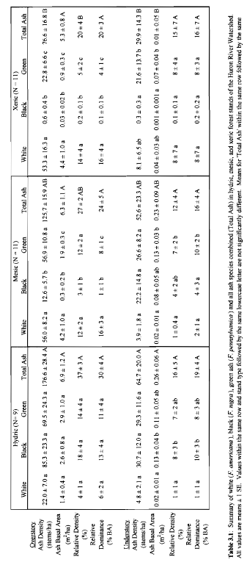

Table. Copied from Klooster et al. 2014.³ The hydric stands had a higher density of ash trees on average, a higher relative density of ash, but only a slightly higher basal area of ash than mesic and xeric stands.
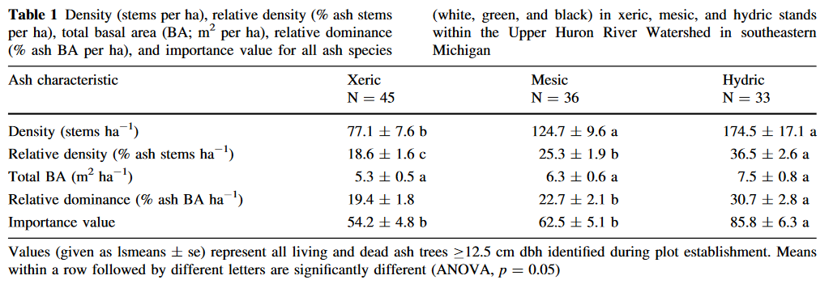

Likely, the density of mature ash trees before the emerald ash borer invasion influenced the density of ash seedlings, saplings, and small trees in the understory. The seedlings and saplings are called “advanced regeneration” and refers to ash in the understory that were present before EAB invasion. When EAB killed most mature trees in the plots between 2004 and 2009 (Klooster et al. 2014, Figure 4)³, the legacy of those ash tree densities would impact densities of ash seedlings and saplings that were not killed.

Interestingly, although ash tree and sapling densities were highest in hydric stands relative to mesic and xeric (in 2009-2010), seedling densities showed a different ranking. In 2009-10, mesic forests had higher seedling densities than xeric forests, which had higher seedling densities than hydric. This suggests that the life history strategies of black ash (which is found predominately in hydric stands) may differ from that of green and white ash (found mostly in mesic and xeric stands, respectively). For black ash, most mortality may occur in the seed germination and new seedling life stages. In contrast, most mortality of green and/or white ash may occur in the transition from established seedling to sapling, or established sapling to tree. These hypothesized differences in life history strategy may be due to the differing abiotic conditions between hydric and mesic/xeric forests. Simply, the first stressor that a tree seedling in a hydric forest must contend with is flooding. The forest floor of hydric sites is often composed of hummocks: small, elevated areas which were once decomposing woody debris. Seedling establishment may depend on the seed germinating in a favorable location for surviving floodwaters, such as a hummock. If a black ash seedling successfully grows into a sapling, it may have passed its period of highest vulnerability. The reduced number of tree species that can survive hydric conditions, along with the decline of trees like American elm (due to Dutch elm disease), may favor the survival of black ash saplings, once they have passed the seedling stage.
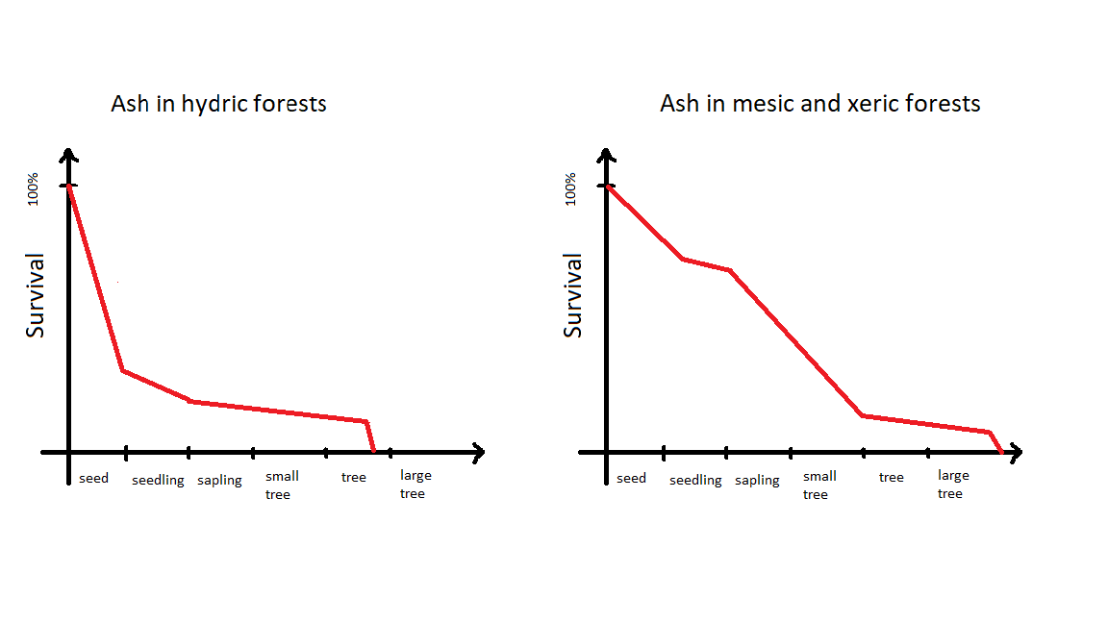
Figure. Hypothesis on the survivorship curves of ash in hydric forests vs. in mesic and xeric forests. In hydric forests, most mortality occurs in seedling germination and seedling establishment. In mesic and xeric forests, most mortality occurs in transitioning from seedling to sapling, sapling to small tree, and small tree to canopy tree.

  - Competition with other plants for sun, water, and/or nutrients

Competition between plants plays an important role in structuring plant communities. Specifically, plants compete in multiple ways, including consumptive competition, pre-emptive competition, and overgrowth competition. Depending on the environmental conditions at a site, plants compete for different resources. Some important resources include sunlight, water, and nutrients. In the Huron River Watershed, the plots we visited encompass a range of environmental conditions, and thus a range of competitive environments, effectively changing “the rules of the competition” between different plant species.

To make predictions about the outcome of competition, we need to know both the “players” (plant species) and the “rules” (the environmental conditions).

Hydrological class | Main players | Rules
Hydric | -Black and green ash  -Red and silver maple  -Elm  -Spicebush  -Buckthorn  -Carpinus  -Winterberry  -Swamp white oak  -Grasses and sedges  -Ferns and skunk cabbage  -Cattails | -Every spring and summer, periodic flooding raises the water table, in some cases creating standing water.  -Trees have a risk of falling if their root systems cannot adequately support them  -The canopy is fairly open due to the many fallen trees and the difficult growing conditions, creating ample light. Additionally, trees are overall shorter than in mesic or xeric forests.  -The ground may be covered in hummocks (places where old tree stumps were) or it can be muddy with lots of skunk cabbage. Certain kinds of ferns, sedges, and grasses can sometimes be found.
Mesic | -Hickory (esp. bitternut hickory)  -Sugar maple  -Red oak and white oak  -Basswood  -Carpinus  -Prickly ash, witchhazel, dogwood, and viburnums | -Here, floods do not usually occur. The ground is often covered in understory wildflowers, ferns, or shrubs, but not always. Leaf litter is the predominate cover at ground level
Xeric | -American hophornbeam  -Ostrya  -Walnut  -Cherry  -White, red and black oaks  -Sassafrass  -Tuliptree  -Celastrus vines | -The ground is usually covered in leaf litter, and usually there are very few understory shrubs. The trees are very tall with a complete canopy cover. However, there are some xeric plots which have a more open canopy, dominated by black walnut at Kensington, and these have more grasses and drought-tolerant understory plants such as Rubus.

While the specific environmental conditions at each transect and plot make it difficult to make generalizations about the processes occurring, my thinking is along the following lines.

In hydric forests, plants compete for sunlight, and flooding acts as a stressor that prevents certain plant species from surviving. The presence of Dutch elm disease and susceptibility of Tamarack to insect-induced mortality mean there are few quick-growing tree species to compete with black and green ash there. The following hypotheses are based on my thoughts after seeing the data for 2024. I think that mortality of the black and green ash in hydric forests caused higher water tables, and this killed some competitor plants. Furthermore, I think the ash advanced regeneration in hydric forests got exposed to high-sunlight conditions for a prolonged period, due to the overall higher canopy openness pre-EAB and the large fraction of the canopy that died with EAB. Thus, I think the black and green ash there grew at a high rate, which explains why we are finding many ash trees in the 2.5-12.5 cm DBH range in hydric forests. As a side effect of the high sunlight in the understory, this created an environment where understory shrubs and grasses, sedges, and ferns could grow prolifically, if they were present and could survive the flooding. Thus, not all hydric plots had high numbers of ash trees in 2024. The overgrown environment at the ground level may make it difficult for ash seeds, if they are produced, to grow and advance into saplings.

  - Mortality due to emerald ash borer

A third factor that plays a role in the abundance of ash saplings, small trees, and trees is the continued presence of emerald ash borer. Because emerald ash borer is killing small trees, and likely saplings too, from the orphaned cohort of ash, this obviously influences their abundance. There might even be heterogeneity in the location where EAB infestations are occurring. For example, if native or introduced parasitoids or bird predation are especially high at a given site, then this could lead to a higher abundance of ash saplings or small trees at that site, because less have been killed by EAB. Importantly, Tetrastichus planipennisi is widespread and is particularly effective at parasitizing EAB in small saplings.

Alternatively, EAB could be dispersal limited such that certain forest sites experienced a complete population crash of EAB after the canopy ash died. If EAB is currently dispersal-limited at the parks we are sampling, then we would not capture any EAB at certain parks, and certain parks would have a complete absence of recent EAB signs.

Another likely phenomenon is that the low-level EAB populations are interacting with plant-plant competition and site quality, such that the orphaned cohort of ash is being killed earlier at smaller sizes in some forests and at larger sizes in other forests, depending on whether the ash trees are stressed by site conditions and competition with neighboring trees.

- White ash (Fraxinus americana) requires moderately well-drained soils, and is commonly found on slopes along major streams.¹ Green ash (Fraxinus pennsylvanica), the most widely distributed Fraxinus and adaptable to many conditions, is more tolerant to seasonal flooding than white ash, and is found in moist bottomland or along stream banks in natural forests.¹ Black ash (Fraxinus nigra), a more northern species, grows in poorly-drained soils with flooding for part of the year.¹ Pumpkin ash has a scattered distribution in the Ohio and Mississippi river valleys and on the Atlantic Coastal Plain, but is also recorded (though rare) in southern Michigan.^{1,4} In the forest plots I visited in 2024, studies of ash species composition were conducted in 2004-2005 by Smith and colleagues.² Xeric transects had majority of basal area as white ash, mesic transects had a mix of white and green ash, and hydric transects had a mix of green and black ash (Smith 2006, Table 3.1).² I predict that the species composition of ash (of all size classes) found in 2024 will generally reflect the pre-EAB species composition as assessed in 2004-05.

However, it remains possible that, due to differences between black and green/pumpkin ash, one of these species has fared better than the other in the time after the initial wave of ash mortality.

- When making a hypothesis about the DBH at which signs and symptoms of EAB occur on ash trees, and how that varies by species, I have plenty of literature to draw on. Creating complexity, some of the sources might be based on the initial wave of EAB invasion, while others on aftermath forests.

Study | Location | What species of ash? | When was canopy ash mortality and when was study done? | What size of ash are being killed by EAB?
Aubin et al. 2015⁵ | Near Windsor, Ontario | Mostly green and white ash – green in riparian sites (n=4), white in woodlots (n=2) | EAB detected in 2002; canopy ash mortality date not mentioned; saplings assessed in 2012 – after canopy mortality | -The biggest living ash trees they found in the aftermath forest were between 5-10.3 cm DBH.  -At each site, 30 regenerating ash >2 cm DBH were evaluated for signs and symptoms, and they were bark peeled to determine presence/absence of EAB. Many saplings were between 2-3 cm DBH, and some were 4-5 cm or 6-7 or 8+.  -On average, 19% of the saplings had EAB in them.  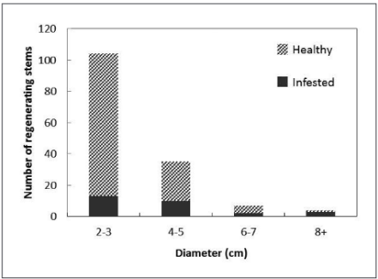  -The visual assessment of sapling vigor was a good predictor of whether EAB was found in bark peeling. Also, the presence of bark cracks and other lesions was also a good predictor of EAB presence in bark peeling.
Ward et al. 2021⁶
Duan et al. 2017⁷ | Southern Michigan | Mostly early successional forests, with mostly green and white ash | Study of ash saplings was done in 2015 | -Healthy (crown class 1 or 2) ash saplings (1-5 cm DBH) were found at a density of 4-16 stems per 100 m², whereas healthy ash small trees (5.1-10.1 cm DBH) were found at a density of 2-9 stems per 100 m². Healthy ash >20 cm DBH were rare. Ash that were larger in diameter were more likely to be declining in canopy condition:  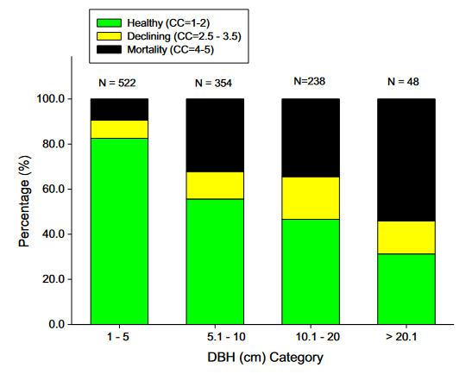
Morris et al. 2023⁸ | Western NY and Eastern NY | Mostly white ash within early successional farm fields (W. NY) or patches of high ash density within oak-cherry forest (E. NY) | EAB detected in 2009 (West) and 2010 (East). Peak EAB densities between 2013-2017. Study of ash was done between 2013-2021. | -A sizable number of the mature ash trees (>10 cm DBH) in Western NY survived.  -Trees evaluated as CC>2 in 2013 largely did not recover and instead died by 2017 or 2021. On the other hand, of trees evaluated as CC=1 or CC=2 in 2013, a sizeable fraction survived and are now healthy.  -Between 2014 and 2021, the total number of ash between 2.5-10 cm DBH declined. However, this was largely driven by the mortality of ash that were already showing symptoms of EAB in 2014. Thus, the number of healthy ash between 2.5-10 cm DBH remained approximately constant from 2014-2021.  -Note: the study also obtained growth rates of tagged ash saplings  -Note: the study also recorded the stem density of ash seedlings (categorized based on being <0.5 m tall, 0.5-1 m, or >1 m tall)
Siegert et al. 2021⁹ | Northern lower Michigan (Presque Isle County and Midland County) | Black and green ash at Ocqueoc, Green ash at Jasper | Ocqueoc: detection was 2004, peak canopy mortality rate from 2007-2009, Post-EAB study done in 2016. Jasper: peak canopy mortality was near 2012, Post-EAB study done in 2019 | -Ocqueoc site:  -99% mortality of stems >13 cm DBH  -mean ash DBH was reduced from 10.8 cm to 6.6 cm between pre-EAB and post-EAB  -black ash trees grew slower, but more consistently from year to year, than green ash trees, based on dendrochronology of EAB-killed canopy ash  -tree saplings (all species of trees) were relatively common at Ocqueoc, and green (44%), black (12%) and white (7%) ash seedlings were common. Also balsam poplar.  -overall seedling density was low, but black ash seedlings made up the biggest fract ion (~60%)  Jasper site:  -100% mortality of stems >13 cm DBH  -mean ash DBH was reduced from 13.8 cm to 4.8 cm between pre-EAB and post-EAB  -saplings of all trees, including ashes, were rare  -red maple seedlings (87%) were especially abundant, whereas green ash seedlings were 9%

Methods

- Where are ash seedlings, saplings, and trees most abundant? Does this vary by hydrology of a transect?

To assess the abundance and health of ash in different size classes, we surveyed the transects described in the study site paragraph. We surveyed ash big trees (>10 cm DBH) within 18 m radius main plots, ash small trees (between 2.5-10 cm DBH) and ash saplings (≥137 cm in height but <2.5 cm DBH) within 8 m radius nested subplots, and ash seedlings (<137 cm in height) within 4 m² area microplots located at cardinal directions from the plot center.

To survey ash seedlings, we counted number of stems in two height categories, <25 cm and >25 cm, and we also estimated the percentage cover of ash seedlings using the scale <1%, 1%, 2-5%, 6-10%, 11-20%, 21-30%, 31-40%, …, 91-100%. Only percentage cover of ash seedlings was included: ash taller than 137 cm was not considered for percentage cover estimates.

For ash saplings, we counted the number of living stems in the subplot, recorded the presence/absence of each ash species if identification was possible, and noted the number of stems exhibiting signs and symptoms of EAB attack. We assessed the presence or absence of multiple features which can indicate that EAB larvae have attacked the vascular system.¹⁰ First, we looked for the presence of D-shaped emergence holes where adult EAB emerge from the bark. Second, we looked for symptoms that are often found on infested trees. These are woodpecker predation marks, bark splitting, epicormic sprouts, and basal sprouts.¹⁰

To inventory the ash trees, including small trees in subplots and big trees in main plots, we recorded information individually for each tree. First, we recorded the DBH of a tree and its species, if possible. Then, we rated the canopy condition using a 1 to 5 scale, where 1 represents healthy canopy foliage, and 5 represents complete defoliation of the canopy. We rated a tree as having canopy condition 5 even if there were small living sprouts on the trunk. After rating canopy condition, we assessed the presence or absence of the EAB signs and symptoms mentioned previously. Basal sprouts were defined as sprouts starting at ground level, while epicormic sprouts were those sprouts starting from the trunk. If two stems of a small tree were clearly connected at the base (for instance, if one stem was the basal sprout of another stem), then we recorded information for the stem which had the larger DBH. Otherwise, we recorded the two stems separately.

From the counts of ash seedlings, saplings, small trees, and trees, we calculated plot-level densities of each size class. We did this by dividing the number of stems by the area over which they were counted. Then we pooled the three plots in each transect together to obtain transect-level mean densities. For ash trees, density of standing dead ash trees (canopy condition = 5) were calculated separately from density of living ash trees (canopy condition < 5). In addition to stem density of ash small and big trees, the basal area of living small and big ash was calculated. Basal area was calculated for each tree individually using the formula Σ(π(d/2)²), where d is the DBH of a tree. Then, the areas of all small trees were summed and then divided by the subplot area, and the areas of all big trees were summed and then divided by the plot area. Basal area was reported in units of m²/hectare.

We used the existing categorization of transects (n=30) by hydrological class (xeric (18 transects), mesic (7 transects), and hydric (5 transects)) to test whether the abundance of ash differs based on soil moisture level. Our response variables were number of short ash seedlings (count), number of tall ash seedlings (count), mean percentage cover of ash seedlings (continuous), number of ash saplings (count), and number of living small ash trees (count). We created separate models for each response variable. Hydrological class (xeric, mesic, or hydric) was treated as the fixed effect and Park where transect is located as random intercepts to account for unique site conditions at each of the seven parks. For each response variable which is count data, we first tried a Poisson generalized linear mixed-effects model (GLMM) with a log link function, implemented using the package ‘lme4’ in R. We used the package ‘DHARMa’ to determine if the observed data was adequately modelled by the GLMM. Specifically, we tested for over- or underdispersion by a data simulation. First, we simulated data based on the fitted parameters of the GLMM, while conditioning on the fitted intercepts for each Park. Then we compared the standard deviation of the observed DHARMa residuals to the standard deviation of the simulated DHARMa residuals, using a nonparametric test. Whenever the Poisson GLMM was determined to be overdispersed (that is, the variance of the observed residuals was higher than that of the simulated residuals), we created a new model using the negative binomial error structure. This was implemented using the ‘lme4’ and ‘MASS’ packages in R. We similarly observed the residuals of the negative binomial GLMM to verify model fit. We compared the AIC between the Poisson and negative binomial models to verify an improvement in model fit. The models for number of saplings and number of small trees were a singular fit or did not converge, so we dropped the random effect of Park for those response variables. Thus, the number of saplings and number of small trees were modelled using a negative binomial generalized linear model with hydrological class as the predictor.

For the mean percentage cover of ash seedlings, each data point was the average cover of ash seedlings across the 12 microplots in a transect, so we treated this variable as continuous. To determine if differences existed in ash seedling percentage cover among transects of different hydrological class, we tried a linear mixed-effects model with normally distributed residuals. However, the model violated the assumption of homoscedasticity of residuals. In response, we transformed the response variable using the formula y’ = ln(y + 1), where y is the mean percentage cover. We then ran a new linear mixed-effects model using the transformed percentage cover. This new model satisfied homoscedasticity of residuals and approximate normality of the residuals, and the random intercepts for each Park were clustered together more than in the original model, showing an approximate normal distribution. The graph is presented using the un-transformed mean percentage cover in the y-axis.

We performed an Analysis of Deviance (Type III Wald Chi Square tests), using the R package “car” to test for differences in the response variables among hydrological classes. We followed up with pairwise comparisons using a p-value adjustment based on the Tukey method for comparing a family of 3 estimates, implemented using the R package ‘emmeans’. We presented figures with the response variables as densities (counts of ash divided by area over which they were counted) even though we conducted analyses using the raw count (natural number) data.

To investigate the number of living big ash trees (≥10 cm) in transects, we presented the results graphically. This is because only two transects had nonzero numbers of ash trees ≥10 cm in their plots. Similarly, the total basal area of ash trees ≥ 2.5 cm was presented graphically.

- Which species of ash seedlings, saplings, small trees, and trees are found at each plot?

The species of ash was assessed using multiple field marks. Due to the near absence of ash seeds to use for identification, we found that we could only consistently distinguish black ash (Fraxinus nigra) from the other Fraxinus species. Black ash was distinguished by its higher number of leaflets per leaf, lanceolate (?) leaf shape, presence of tomentum where leaflets meet on the rachis, and presence of corky bark. Although white ash can be distinguished from green ash by its longer petiolules and horseshoe-shaped leaf scars, we found these characters too variable to permit reliable identification. We grouped our species designations into three categories: 1) black ash 2) all other species of ash but not black ash (including white ash, green ash, and potentially pumpkin ash), and 3) unknown ash species (often because the tree was dead). We reported the stem densities and basal areas of the species categories for each transect where ash was present.

- What percentage of ash saplings, small trees, and trees have signs and symptoms of EAB attack? What minimum diameter of ash is EAB attacking? Does this vary by ash species? Are black ash or green/white/pumpkin ash dying at smaller sizes?

As mentioned previously, we recorded the presence or absence of EAB signs and symptoms on individual ash small and big trees, and at the plot level for saplings.

To analyze the sapling data, we reported the fraction of total saplings (>= 137 cm height and <2.5 cm DBH) exhibiting any signs and/or symptoms of EAB attack. We also reported the most common EAB sign or symptom that was found on saplings.

To analyze the tree sign and symptom data, we first calculated the percentage of trees showing each EAB sign or symptom.

To test the prediction that ash tree diameter is positively correlated with signs and symptoms of EAB attack, we used binomial generalized linear mixed-effects models with logit link functions. Diameter at breast height (DBH) was the fixed effect. We included plot as a random intercept to account for non-independence of trees in a plot. We excluded any tree belonging to a plot where less than 10 trees were found, which gave us a sample size of 274 trees. We further removed two trees which had missing values for presence of basal sprouts, which brought our sample size to 272 trees. These were in 9 Plots, within 6 Transects at 3 different Parks (Indian Springs, Island Lake, and Proud Lake). Five of the 6 transects in the analysis were classified as hydric, and 1 (Transect “CC” at Island Lake) was classified as mesic. We considered including ash species in our model, because the susceptibility to EAB attack could vary by species. However, usually only one species of ash tree would comprise most of the ash trees in a given plot, making it difficult to decouple plot and ash species as predictors. To assess the accuracy of the models, we created binned categories of tree diameter and calculated the proportion of trees in each bin that showed the sign or symptom. We observed whether our model line passed through the proportions for each bin.

For the analysis of the canopy condition of ash trees (the stage of defoliation), this variable was initially recorded on a 1-5 scale, with 1 being a healthy canopy and 5 representing complete defoliation. To convert this measure into binary response variables, we create a response called “ash tree death” which was defined as 1 if canopy condition = 5, and 0 if canopy condition was between 1-4. We also created a response called “ash tree decline” which was defined as 1 if canopy condition was ≥ 2, and 0 if canopy condition = 1. We then analyzed these response variables similarly to the other signs and symptoms of EAB attack.

Finally, we presented a graphical depiction of the relationship between ash tree DBH, species, and canopy decline.

Results

- Where are ash seedlings, saplings, and trees most abundant? Does this vary by hydrology of a transect?

Transects that varied in their hydrological class, from hydric forest with water-saturated soil, to xeric forest in drier upland sites, were investigated for the occurrence of ash in various size classes. All metrics of ash abundance are reported at the transect level, which consisted of three plots.

Ash seedlings (<137 cm in height)

A total of 2826 ash seedlings were counted in the microplots of the 30 transects. Ash seedlings were found in stem densities ranging from 0 to 5.4 stems/m², with an average of 2.0 stems/m². Short (<25 cm) and tall (25-137 cm) seedlings averaged 1.1 stems/m² and 0.9 stems/ m², respectively. The transect with highest number of short ash seedlings was “X”, a mesic transect at Highland Recreation Area. The transect with highest number of tall ash seedlings was “V”, a mesic transect at Indian Springs Metropark. Mean percentage cover of ash seedlings ranged from 0% to 38%, with an average of 12% across all transects. The transect with highest mean percentage cover of ash seedlings was “ZC”, a xeric transect located at Pontiac Lake Recreation Area.

Number of short ash seedlings varied by hydrological class (χ²=10.9, 2 degrees of freedom, p=0.004). Hydric transects had lower numbers of short seedlings than mesic (Z=-3.3, p=0.003) and xeric (Z=-2.6, p=0.027) transects, while differences between mesic and xeric transects were not statistically significant (Fig. 1A). Similarly, number of tall ash seedlings differed by hydrological class (χ²=12.7, p=0.002), with hydric transects having lower numbers than either mesic (Z=-3.5, p=0.001) or xeric (Z=-2.7, p=0.019) transects (Fig. 1B). In mesic and xeric transects, the percentage cover of ash seedlings averaged 17% and 12%, respectively, but hydric transects had only 3% ash seedling cover on average. Percentage cover of ash seedlings varied by hydrological class (χ²=12.4, p=0.002), with hydric transects significantly lower than mesic transects (t=-3.2, p=0.010) and xeric transects (t=-3.0, p=0.018) (Fig. 1C).

Ash saplings (≥137 cm in height and <2.5 cm DBH)

A total of 897 saplings were counted in the 30 transects. The density of ash saplings, across the 30 transects, ranged from 0 to 0.539 stems/ m² (0-5390 stems/hectare), with an average of 0.050 stems/ m² (500 stems/hectare). The transect with maximum number of saplings was “ZG”, a xeric transect located at Kensington Metropark which had a somewhat open canopy of black walnut (Juglans nigra). Any differences in number of saplings based on transect hydrological class were not significant (χ²=0.4, p=0.82) (Fig. 1D).

Ash small trees (2.5-10 cm DBH)

A total of 187 small ash trees were found in the 30 transects. Of these, 149 were living (canopy condition ≠ 5), while 38 were dead and at least partly standing. The density of living small ash trees ranged from 0 to 1011 stems/hectare, with a mean of 82.3 stems/hectare and a median of 0 stems/hectare. The transect with the highest number of small trees was “H”, a hydric transect at Proud Lake Recreation Area. The number of living small ash trees varied by transect hydrological class (χ²=8.38, p=0.015). Hydric transects had more small ash trees than xeric transects (Z=2.5, p=0.033), but the other pairwise comparisons were not significant (Fig. 1E).

Ash big trees (≥ 10 cm DBH)

Only 9 trees were found in the 30 transects, of which 7 were living (Fig. 1F). The two transects where living big ash trees were found were “H”, the same transect that had the highest numbers of small ash trees, and “S”, a hydric transect at Indian Springs. Living big trees within the plots ranged in diameter from 10.3 cm DBH to only 12.4 cm DBH.

Basal area of ash

The basal area of living small and big ash trees combined (all ash ≥ 2.5 cm DBH and canopy condition ≠ 5) ranged between 0 and 2.61 m²/hectare, with an average of 0.18 m²/hectare. The transect with highest basal area of living ash trees was transect “H” at Proud Lake.

B
A
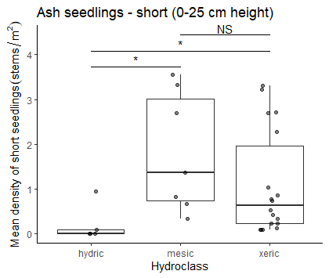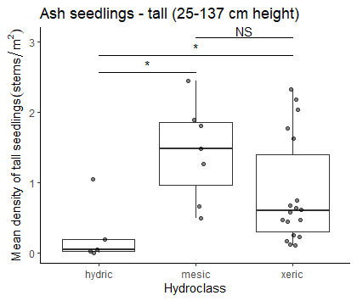
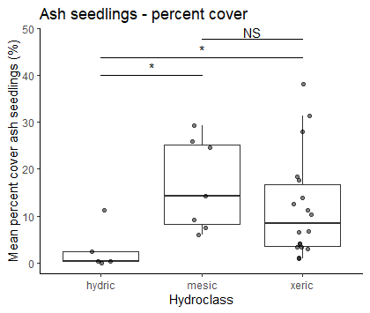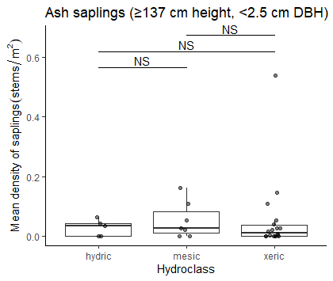
F
E
D
C
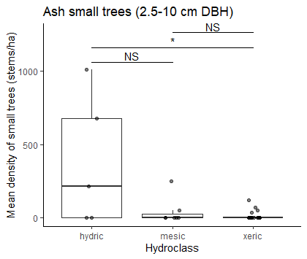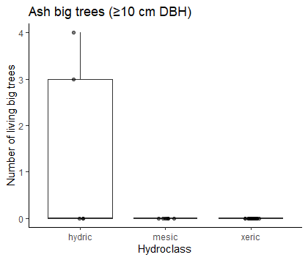

Figure 1. Ash occurrence by size category in 30 transects varying in soil hydrological class. A) Mean density of short ash seedlings, B) mean density of tall ash seedlings, C) percentage cover of ash seedlings, D) mean density of ash saplings, E) mean density of small ash trees, F) total counts of big ash trees.

- Which species of ash seedlings, saplings, small trees, and trees are found at each plot?

Ash seedlings and saplings

More than one species of ash seedlings and saplings were found in the study transects. Both black ash and green, white, or pumpkin ash saplings were found. Multiple species of ash sapling were often found co-occurring in a single plot. However, difficulty in identification made statistical analyses of the results impractical.

Ash small trees

For this analysis, we included trees found within plots of transects that have not been completed yet as of 2024. This is 97 plots rather than the 90 plots used for the previous analysis. In the 97 plots, we found 313 small trees. Of these, 177 (56%) were black ash, 115 (37%) were green, white, or pumpkin ash, and 21 (7%) were not identified. In hydric forests, out of 271 trees, there were 155 black ash small trees, 102 green, white, or pumpkin ash, and 14 unidentified ash small trees. In mesic forests, out of 20 small ash trees, 16 were black ash and 4 were unidentified. In xeric forests, out of 22 small ash trees, 6 were black ash, 13 were green, white, or pumpkin, and 3 were unidentified.

When analyzing just the 30 transects that have been completed, we observed that many hydric transects were composed mostly of black ash small trees, with only a few green or pumpkin ash. However, some hydric transects had higher numbers of green or pumpkin ash (Fig. S2).

Ash big trees

Out of 9 big ash trees, 4 were black ash, 3 were green, white, or pumpkin ash, and 2 were unidentified ash species.

- What percentage of ash saplings, small trees, and trees have signs and symptoms of EAB attack? What minimum diameter of ash is EAB attacking? Does this vary by ash species? Are black ash or green/white/pumpkin ash dying at smaller sizes?

Saplings (≥ 137 cm height, <2.5 cm DBH)

Out of a sample size of 994 saplings (this includes data from 97 plots), signs or symptoms of possible EAB attack were found on a total of 55 saplings. By far the most common sign or symptom on saplings was bark splitting, which was found in 31 subplot quadrants out of 150 subplot quadrants with ash saplings. Other signs and symptoms of EAB were relatively rare or absent on ash saplings, including EAB exit holes (not found on saplings), woodpecker predation marks (found in 1 subplot quadrant), epicormic sprouts (found in 6 subplot quadrants), and basal sprouts (found in 3 subplot quadrants.

Trees (≥ 2.5 cm DBH)

Small and big ash trees were pooled for this analysis. Out of a total of 320 trees, 220 (69%) had canopy condition=1 (meaning they were healthy), 31 (10%) had canopy condition=2, 12 (4%) had canopy condition=3, 7 (2%) had canopy condition=4, and 50 (16%) had canopy condition=5 (meaning they had a dead canopy).

The diagnostic sign of EAB presence, the exit holes where adult EAB emerged from a tree, were relatively rarely found, with only 8 ash trees (2%) out of 321 having exit holes that were found (Fig. S1).

Of the symptoms of EAB, bark splitting was the most common and was found on 179 (56%) out of 321 ash trees. Epicormic sprouts were second-most common, found on 116 (36%) of ash trees. Basal sprouts and woodpecker predation marks were found on 46 (14%) and 40 (12%) ash trees, respectively.

Relationship between ash tree diameter and EAB signs and symptoms

The presence of woodpecker predation marks was positively correlated with tree diameter (DBH), with a 1 cm increase in DBH increasing the odds of woodpecker marks by 130% (Z=2.96, p=0.003) (Fig. 2A). The relationship between DBH and bark splitting was not significant (Fig. 2B). Presence of epicormic sprouts was positively correlated with DBH, with a 1 cm increase in DBH increasing the odds of epicormic sprouts by 130% (Z=3.27, p=0.001) (Fig. 2C). The relationship between DBH and presence of basal sprouts was not significant (Fig. 2D). Additionally, the relationship between DBH and the tree having a canopy condition of 5 (meaning it is dead) was not significant (Fig. 2E). The presence of canopy foliage decline (canopy condition of 2-5) was positively correlated with DBH, such that a 1 cm increase in DBH increased the odds of canopy decline by 126% (Z=3.26, p=0.001) (Fig. 2F).

When examining the proportions of trees showing symptoms for groups binned by DBH, we noticed that the 9.5-10.5 cm group and the 10.5-11.5 cm group had lower-than-expected proportions of trees showing symptoms of EAB attack (Fig. 2, red triangles). Thus, the binomial GLMMs are not perfectly modelling the observed patterns.

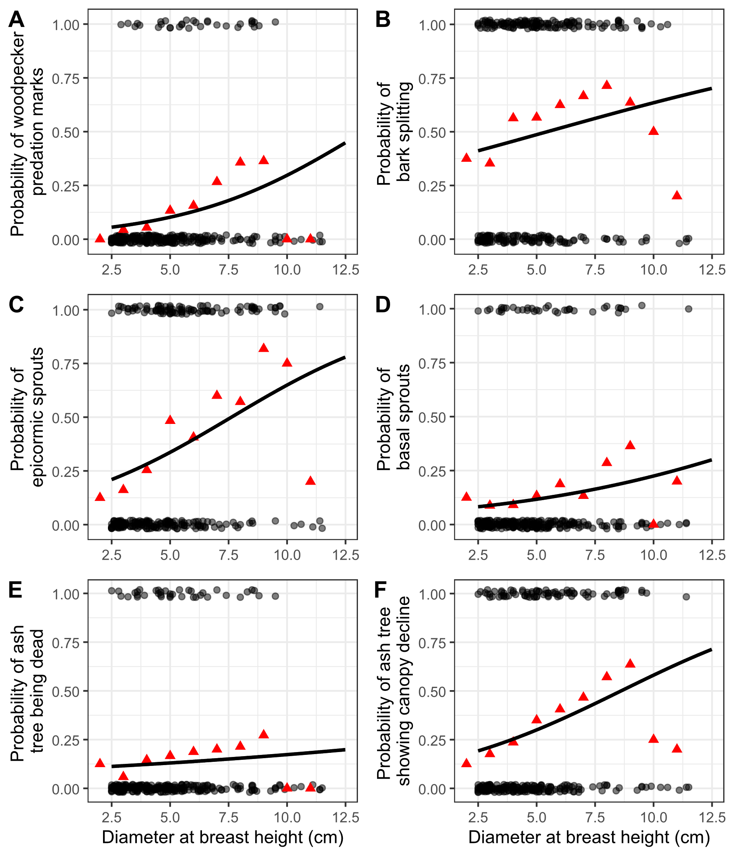
Figure 2. The presence or absence of symptoms of EAB plotted against tree diameter at breast height (DBH) for 272 trees in 9 forest plots. Grey circles are individual trees, which are plotted as y=1 for presence or y=0 for absence (points were jittered slightly up and down). Black line shows the overall fitted model, disregarding each specific random intercept for each plot. Red triangles show the proportion of trees within a DBH bin that have the symptom. For E, tree death is defined as a canopy condition of 5. For F, canopy decline is defined as a canopy condition between 2-5 (minor to complete defoliation).

Relationship between ash species, tree diameter, and canopy condition

The relationship between ash species, DBH, and canopy condition was investigated. Because the majority (280 out of 322) of ash trees (≥ 2.5 cm DBH) were found within hydric plots, we decided to subset the data to hydric plots for investigation of differences between ash species. After removing ash trees which were unidentified (17 trees) or with missing canopy condition (1 tree), we obtained a sample size of 157 black ash (Fraxinus nigra) trees and 105 trees which were either green ash (Fraxinus pennsylvanica) or pumpkin ash (Fraxinus profunda).

A higher proportion of the black ash trees were declining or dead, compared to the green and pumpkin ash, in the plots we surveyed (Figure 3). In contrast, in the 7.5-10 cm DBH range, there were nevertheless still more healthy (canopy condition = 1) black ash than green and pumpkin ash.

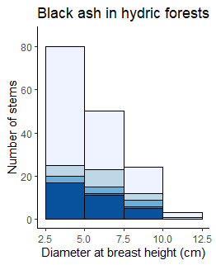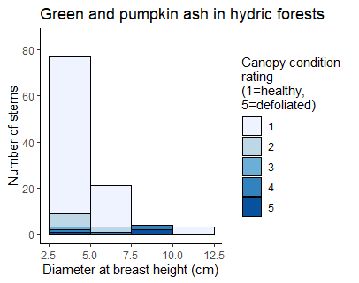
B
A
Figure 3. Histogram of ash tree diameter for different ash species found in hydric forests, shaded by canopy condition rating. The x-axes show diameter at breast height and the y-axes show aggregated counts of all trees found within plots. Bars are shaded according to the number of trees with each canopy condition rating, with darker shades indicating more canopy decline. Trees above 10 cm DBH were counted in 18 m radius main plots, while trees below 10 cm DBH were counted in 8 m radius subplots. A) Black ash (Fraxinus nigra) B) Green ash (Fraxinus pennsylvanica) and possibly pumpkin ash (Fraxinus profunda), which were not separated during species identifications.

Supplementary figures

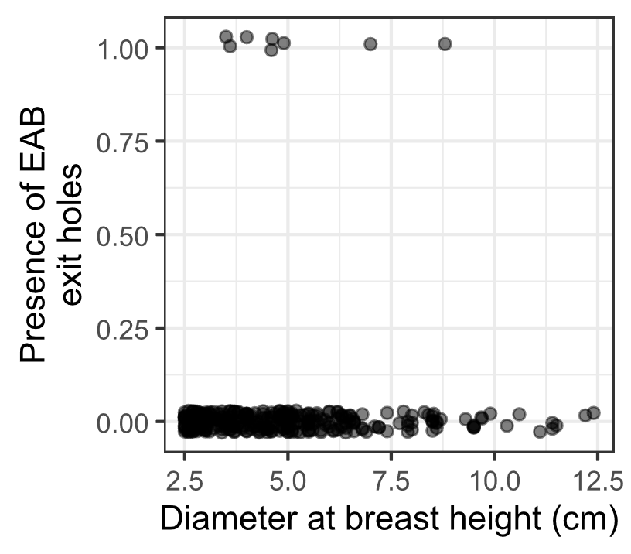
Figure S1. The presence or absence of visible EAB exit holes on the trunk at around eye level. Only 8 of 321 ash trees had EAB exit holes that were spotted.

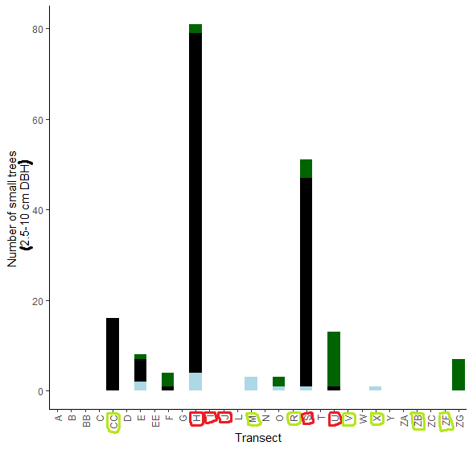
Figure S2. The total number of small ash trees (2.5 – 10 cm DBH) found in 30 completed transects in the Upper Huron River Watershed. Small ash of all canopy conditions are counted. Hydric transects are circled in red, while mesic transects are circled in light green. Bars are shaded based on the proportion of each ash species that was found in a transect. Dark green represents green, white, and/or pumpkin ash; black represents black ash; light blue represents unknown species.

References

1. Burns, R. & Honkala, B. Silvics of North America: Volume 2, Hardwoods. vol. 2 (1990).
2. Smith, A. Effects of Community Structure on Forest susceptibility and Response to the Emerald Ash Borer Invasion of the Huron River Watershed in Southeast Michigan. (The Ohio State University, 2006).
3. Klooster, W. S. et al. Ash (Fraxinus spp.) mortality, regeneration, and seed bank dynamics in mixed hardwood forests following invasion by emerald ash borer (Agrilus planipennis). Biol Invasions 16, 859–873 (2014).
4. Kartesz, J. T. The Biota of North America Program (BONAP). (North American Plant Atlas. (http://bonap.net/napa), Chapel Hill, N.C., 2015).
5. Aubin, I., Cardou, F., Ryall, K., Kreutzweiser, D. & Scarr, T. Ash regeneration capacity after emerald ash borer (EAB) outbreaks: Some early results. The Forestry Chronicle 91, 291–298 (2015).
6. Ward, S. F., Liebhold, A. M., Morin, R. S. & Fei, S. Population dynamics of ash across the eastern USA following invasion by emerald ash borer. Forest Ecology and Management 479, 1–8 (2021).
7. Duan, J. J., Bauer, L. S. & Van Driesche, R. G. Emerald ash borer biocontrol in ash saplings: The potential for early stage recovery of North American ash trees. Forest Ecology and Management 394, 64–72 (2017).
8. Morris, T. D., Gould, J. R., Drake, J. & Fierke, M. K. Status of ash forests and regeneration a decade after first detection of emerald ash borer infestation in New York state. Forest Ecology and Management 549, 121464 (2023).
9. Siegert, N. W., Engelken, P. J. & McCullough, D. G. Changes in demography and carrying capacity of green ash and black ash ten years after emerald ash borer invasion of two ash-dominant forests. Forest Ecology and Management 494, 119335 (2021).
10. Knight, K. S. et al. Monitoring Ash (Fraxinus Spp.) Decline and Emerald Ash Borer (Agrilus Planipennis) Symptoms in Infested Areas. https://www.fs.usda.gov/research/treesearch/46655 (2014).

